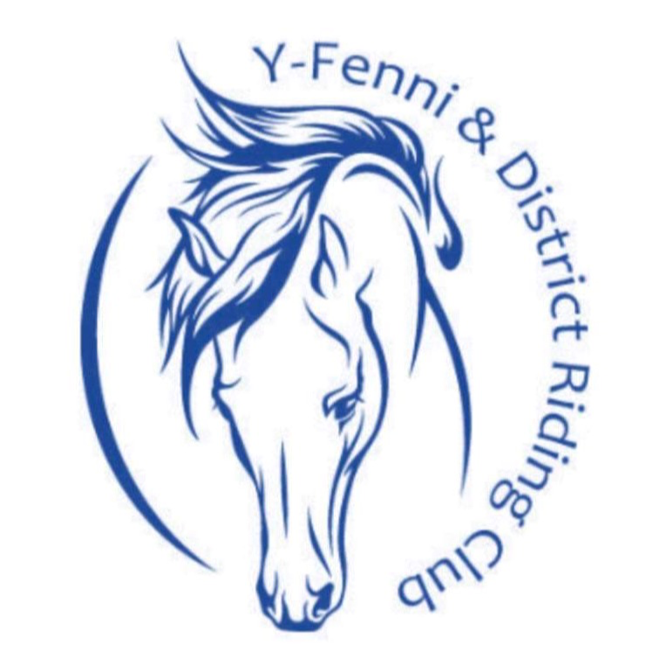  Risk Assessments | Sport/Activity | Riding Club Show | Date of Event
 | Event | Annual YFRC Show | Post Code
 | Location |  | What3Words

Hazard | Who might be injured? | Risk Controls  (already in place) | Further Action Required | Allocated Person / Date | Completion Date and Initial
What is the injury?  How can the injury occur? | E.g. people (members, volunteers, spectators, etc), animals, vehicles. | What is currently being done to prevent the injury occurring? | What more needs to be done? | Who is responsible for completing the action?  What is the planned time frame for this? | Initial and date when action is completed
Event layout: Impact between vehicles,  Vehicles vs pedestrians, Vehicles vs horses | RC Members and spectators may become injured if impact occurs between vehicles, pedestrians and/or competitors. Vehicles could be moving too quickly or may not see the pedestrians. | Vehicle free area for pedestrians.  Wide horse access route from lorry parking to arena.  No-go vehicle areas, no-go horse areas where required by site occupiers. | During the event, ensure controls and compliance are monitored by YFRC appointed person.  Local risk controls by site occupier to be enforced. | YFRC appointed person to monitor
Slip or trip hazards from ground conditions or in officials’ area | RC Members and spectators may be injured from slip or trip injuries while on site. | Ground conditions and any significant slip or trip hazards have been identified and removed or segregated.  The official’s area gazebo/table and chairs will have footing and lines clearly identifiable to reduce trip hazard. | During the event, ensure controls and compliance are monitored. | YFRC appointed person to monitor
Trip injuries from routing of cables and pipes. | RC Members, officials, spectators, the general public and horses may be injured due to a tripping hazard of trailing wires or flexible hose and pipe. | Cables must be run at high level, in a safe area, or covered where possible.  Cables/ pipes must be run away from main pedestrian area and be in a high visibility colour to enable them to be highly visible. | During the event, ensure controls and compliance are monitored. | YFRC appointed person
Impact and crush injuries from falls or contact with horses.  Included but not limited to ridden activity, officials checks and engaging with the judge. | RC Members and spectators may become injured if crush or impact occurs by being kicked, trodden on or crushed by close proximity to a horse. | It is the riders/handler’s responsibility to ensure their horse is under control at all times.  Safety lines/ fences are marked next to the arenas and no spectators are allowed with the safety lines while Activity is ongoing.  Pedestrians stood in close proximity to horses must be responsible for their own safety and the possibility of crush from hoof to foot contact.  Pedestrians and handlers should avoid standing directly behind horses.  Any horses that are known to kick must wear a red ribbon in the tail.  All riders must wear an approved riding hat at all times when mounted in compliance with British Riding Club rules.  Congestion building up with horses around entrances to the arena must be monitored and riders/handlers will be asked to move away to create space.  It is the parent/rider/handler responsibility to ensure all horse tack is safe, sound, secure and fits correctly.  Arena, warm up areas and competition areas are to be monitored by stewards who can seek assistance in the event of an accident | During the event, ensure controls and compliance are monitored. | YFRC appointed person to monitor
Impact or crush injury when using the arena facility and activity equipment. | Impact or fall injury due to inadequate facility or incorrect equipment used in riding activities. | Equipment checked before each group as required.  arena and equipment are changed and altered based on activities and rider abilities by the competent instructor.  Surface Conditions are monitored and are safe.  Any other requirements from the site occupier are taken into account.  Arena, warm up areas and competition areas are to be monitored by stewards who can seek assistance in the event of an accident | · Equipment to be checked by each instructor prior to each rides use.  · Any damaged equipment reported immediately and remove from use if required.  · YFRC officials will check the arenas and construction of these on set up of event, prior to activity and during the event  · Team Manager, parent and official to monitor rider ability and surface conditions.  · Local risk controls by site occupier to be enforced. | YFRC appointed person to monitor.
Impact and crush injuries from loose horses. | RC Members, members of the public and spectators may become injured if impact occurs between them and a loose horse | In the case of a loose horse, a warning of ‘LOOSE HORSE’ must be shouted and action taken immediately to prevent the horse escaping onto the road.  Horses will be penned appropriately.  Where possible physical barriers or gates must be in place to prevent loose horses reaching a public road.  When not being ridden horses will be kept in a secure pen or ties to a fixed point | All attendees must be aware to attempt to prevent a loose horse reaching the road if a shout of ‘LOOSE HORSE’ is heard.  If possible, ensure access gate is closed during riding activities.  During the event, ensure controls and compliance are monitored. | YFRC appointed person to monitor
Injuries to young and inexperienced riders due to inability to control horse. | RC Members and spectators may become injured if impact occurs between them and a horse or the rider falls from the horse. | Direct supervision as required.  Specific polocrosse instruction/ supervision must be given the case of novice riders.  Appointed person to brief instructors before start of the tournament/ session.  Parent/ guardian/ YFRC Official/ Instructor must ensure activity is suitable for the ability of the rider.  Move riders in group not suitable for their ability or pony.  Parent / helper assistance for younger / novice riders if needed.  Communication methods agreed.  Facilities and equipment suitable for each ride's ability.  Arena, warm up areas and competition areas are to be monitored by stewards who can seek assistance in the event of an accident | Team Managers, parent and officials must ensure each activity is suitable for the ability of the rider.  Instructors with up-to-date competence certificates.  DBS, Safeguarding and First Aid,  Mobile phones charged and available.  Emergency procedure in place. | Team Managers/ officials to monitor competence.  YFRC appointed person to monitor
Crush or impact from use of mobile machinery. | RC Members and spectators may be injured from contact with mobile machinery such as tractors. Horses may also be injured depending on where the machinery was being operated. | Machinery must not be operated in close proximity to riding club members and horses during the event.  Machinery must only be operated by Competent operators.  All machinery must be operated in a clear working area. | During the event, ensure controls and compliance are monitored. | YFRC appointed person to monitor
Official, judges or emergency vehicles  in pedestrian areas: Impact with vehicles, pedestrians and horses | RC Members and spectators may become harmed if official emergency vehicles are travelling too quickly, they may collide with pedestrians and injure them. | Limit number of vehicles, designated routes, designated pedestrian and horse movement areas.  Where ponies/ horses and riders need to cross a vehicle route a Marshall will be provided for all hours of the competition.  Dedicated routes (horse walks). Crossing points for equine and riders warming up or entering the competition.  Judges and other officials’ vehicles will move in a time slot provided to limit possible contact with equines/ riders.  Emergency vehicles attending must be shown the correct access route and warned of the number of pedestrians on site.  area monitored by stewards who can seek assistance in the event of an accident | During the event, ensure controls and compliance are monitored. | YFRC appointed person to monitor
Injury severity being increased due to slow or delayed first aid treatment. | RC Members, spectators and the general public may have the severity of any injuries received increased by slow or delayed first aid provision. | Competent qualified first aiders will be present on the day of the event.  The first aiders will have adequate amounts of the correct type of first aid provision.  Suitable medical helicopter landing areas are available.  Site location identified by postcode and What3Words.  Mobile phone signal or land line available. | None | YFRC appointed person to monitor
Injury severity increased due to incorrect diagnosis of concussion | RC Members and may be concussed and mis-diagnosed. | Medical provision and First aiders are trained in recognising concussion.  Clear rules on when to continue following a fall.  Clear injury reporting procedure. | During the event, ensure controls and compliance are monitored. | YFRC appointed person to monitor | On the day of the event.
Impact or impalement injuries from contact with, fencing, stakes and roping: | RC Members, spectators, the general public and horses can become injured by contact with, fencing, stakes and roping by getting too close to them or tripping over them. The general public may become injured by roping if they don’t see It and trip over it. | All ring fence posts are to be an approved type with a large enough diameter to prevent impalement if a rider falls onto the post.  Unprotected metal posts are not to be used.  Rope is to be high contrast in colour to provide a good contrast against the background to make it visible.  Fence posts to be secured adequately.  Arena, warm up areas and competition areas are to be monitored by stewards who can seek assistance in the event of an accident |  | YFRC appointed person to monitor
Impact injury due to contact with cable used for support of overhead power line posts. | Horses and pedestrians may slip of fall due to tripping or contact with overhead power line post supporting ground cables | Cables fenced off to eliminate contact.  Barriers used to highlight presence of cable and prevent contact. | None | YFRC appointed person
Members of the public using footpath route being injured by horses. | Members of the public may come into contact with horses due to close proximity of public footpath across event area. | Footpath roped off to provide physical separation barrier between pedestrians and horses.  Clear footpath route established to provide safe access route.  Signs erected to direct pedestrians safely across event area.  Marshals provided with guidance to direct pedestrians along safe route.  Safe route shown on site layout plan. | Marshals to instruct pedestrians of safe route on the day. | YFRC appointed person
Losing someone on site and delayed medical care due to unknown location | Officials, competitors, visitors and general public | Team Managers, parents and organisers will have contact information for all in their party.  Site will be locked down and no entry/ exit will be allowed until search has been carried out. Activity will be suspended during search. Search to be carried out by YFRC Officials  Once lost person is found event activity can resume.  In event lost person is not found, additional steps to involve emergency services and notify British Riding Club trustees/ management will be taken | During the event, ensure controls and compliance are monitored | YFRC appointed person
Adverse weather conditions impacting rider or equine wellbeing: visibility, heat stroke, dehydration, hypothermia | Member, Equine and parent/ guardian or Official | Visibility during a event may be impacted, guidance on what to do in these circumstances given in briefing  Hot temperatures could impact on the rider and equines welfare and health, parent/ guardian can ensure water available.  Cold, wet, windy and rain/ snowy days can impact visibility, result in hypothermia.  To mitigate riders advised of appropriate clothing for rider and equine alike, provided with warm drinks provided at intervals and monitored throughout event. Additional clothing/ dry clothing may be provided as necessary for rider or equine.  Event may cancel due to weather conditions, if deemed unsafe to continue by organiser. | During the event, ensure controls and compliance are monitored. | YFRC appointed person to monitor
Equine: bio security: horses could become ill whilst at the event and need medical care | Horses and ponies | All horses and ponies in attendance will meet the vaccination requirements of the British Riding Club as per its current rules.  Penning will be separate to limit contact between equines.  Stables will be thoroughly cleaned and disinfected between uses.  Out of hours a vet will be on call out of hours for those remaining on site and able to support should the need arise.  Equines will be vetted out of the event if they are unwell and there is a health concern. This will need a vet sign off.  Relevant veterinary advice will be sought based on the situation and need to ensure welfare of the equines at the event. | During the event, ensure controls and compliance are monitored | YFRC appointed person
Harm to an individual’s rights, wellbeing and mental/ physical being | Members, parents, guardians, officials and pedestrians | The organisation has members of staff to support with safeguarding of all involved at our activities. The Pony Club Safeguarding policy outlines the processes which should be adhered to.  Those who regularly come in to contact with members, e.g Coaches and officials or those in a position of responsibility, must meet compliance checks.  Coaches level of supervision is determined by their qualifications.  Camps, Competitions, Residentials and excursions are carried out including the provision of supervision and ratios of staffing.  Members, parents, guardians, volunteers and officials adhere to the respective Code of Conduct and steps are taken should this not be followed.  All measures identified in the Health and Safety Rulebook are adhered to, including first aid and accident reporting.  Members medical needs are identified through medical consent form and steps agreed with the parent/ guardian and nominated official to administer and store medication including record keeping.  The organisations Drugs and Alcohol Policy is adhered to. | A named safeguarding lead is appointed at activities and is present.  Monitor and ensure compliance | YFRC appointed person to monitor
Harm due to medical treatment of equine.  Injury could be crush, cut, bruise and glancing blow. | Members, parents, guardians, officials and pedestrians | Local vets have been alerted to the event.  All incidents are recorded in line with The Pony Club procedures.  If required by the Health and Safety Rulebook. Vet Matrix are in attendance, contact information is shared with attendees.  First Aid Provision in place which is in line with the Health and Safety Rulebook. First Aid Matrix, attendees are aware of how to contact First Aid.  On site first aid have been alerted that these is an injured equine and those attending may need assistance.  A suitable location for the treatment of equines at the event has been identified prior to the event.  Appropriate Personal Protective Equipment (PPE) is worn to aid treatment of the equine. Where necessary PPE meets the required safety standard.  Treatment is only administered by/ with approval of the owner.  The equine is handled during treatment by suitable adult(s) and instructions are followed.  The injury is assessed and severity. Veterinary assistance is sought as needed.  Appropriate medical treatment administered/ stored in line with item instructions and COSHH guidance supplied with the product | Monitor and ensure compliance | YFRC appointed person to monitor
Prize giving: slip, trip, fall on or off the podium/ stage | RC Members and spectators may be injured from slip or trip injuries while on site. | Ground conditions and any significant slip or trip hazards have been identified and removed or segregated.  The areas will have footing and lines clearly identifiable to reduce trip hazard.  The podium/ stage should be of adequate size and construction | During the event, ensure controls and compliance are monitored. | YFRC appointed person to monitor

Risk assessment completed by: | Date completed: | Review Date:
Name:
Signed:

