 | MOVEMENTS | MAX MARK | JUDGES MARK | COMMENTS
1 | A Enter working trot  C Turn left  H E K Working trot | 10
2 | K ½ 10m circle left to D  Returning to track between E & H  H C Working trot | 10X2
3 | Between C & M Working canter right  B Circle right 20m  F Trot  A Walk | 10
4 | K B M change rein free walk long rein  M C Walk | 10X2
5 | C Trot  E Turn left  B Turn right | 10
6 | F ½ 10m Circle right to D  Returning to track between B & M  M C Trot | 10X2
7 | Between C & H Working Canter Left  E Circle left 20m  K Trot | 10
8 | A Turn down centre line  Between D & X Walk  X Halt Salute | 10
9 | Regularity & Rhythm of Paces | 10X2
10 | Submission & Acceptance of Aids | 10X2
11 | Impulsion, Suppleness & desire to move forward | 10X2
12 | Position of Rider & Correctness of aids | 10X2
 | TOTAL | 190
 | ERRORS |  | 2 Marks to be deducted for each error
TOTAL MARKS |  |  | PERCENTAGE
JUDGES NAME:  SIGNATURE:  DATE: |  |  | JUDGES COMMENTS
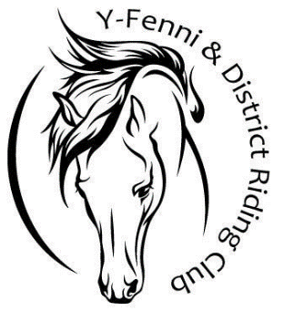
Y FENNI & DISTRICT RIDING CLUB PRELIM TEST G

NAME OF RIDER:_____________________________________________
NAME OF HORSE:____________________________________________

